Project Design Phase-II Technology Stack (Architecture & Stack)

|  |  |
| --- | --- |
| Date | 21 October 2022 |
| Team ID | **PNT2022TMID2384** |
| Project Name | Emerging Methods for Early Detection Of Forest Fires |
| Maximum Marks | 4 Marks |

# Technical Architecture:

The Deliverable shall include the architectural diagram as below and the information as per the table1 & table 2

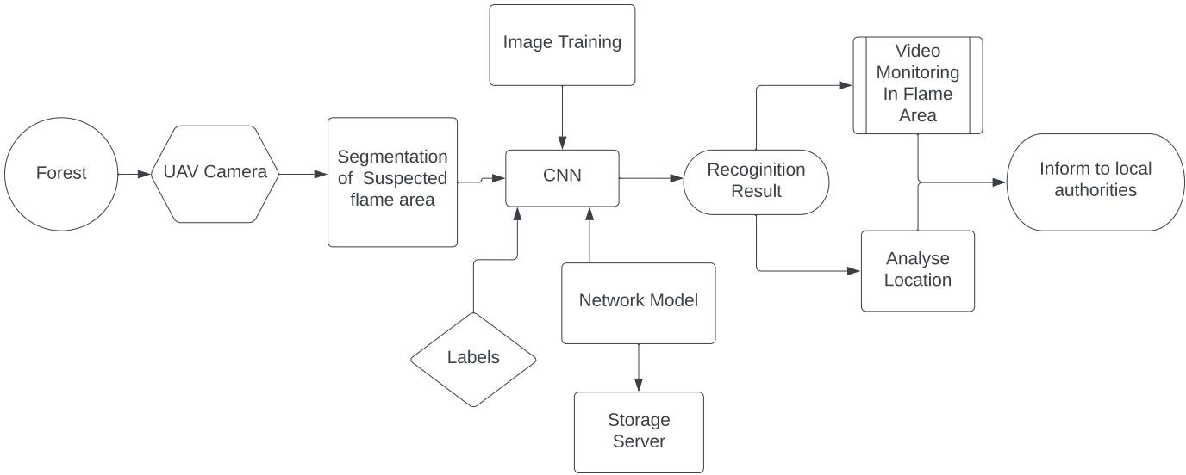

# Table-1 : Components & Technologies:

|  |  |  |  |
| --- | --- | --- | --- |
| **S.No** | **Component** | **Description** | **Technology** |
| 1. | User Interface | How user interacts with application e.g.  Web UI, Mobile App, Chatbot etc. | HTML, CSS, JavaScript / Angular Js /  React Js etc. |
| 2. | Application Logic-1 | Logic for a process in the application | Java / Python |
| 3. | Application Logic-2 | Logic for a process in the application | IBM Watson STT service |
| 4. | Application Logic-3 | Logic for a process in the application | IBM Watson Assistant |
| 5. | Database | Data Type, Configurations etc. | MySQL, NoSQL, etc. |
| 6. | Cloud Database | Database Service on Cloud | IBM DB2, IBM Cloudant etc. |
| 7. | File Storage | File storage requirements | IBM Block Storage or Other Storage Service or Local Filesystem |
| 8. | External API-1 | Purpose of External API used in the application | IBM Weather API, etc. |
| 9. | External API-2 | Purpose of External API used in the application | AOI API etc. |
| 10. | Machine Learning Model | Purpose of Machine Learning Model | Object Recognition Model, etc. |
| 11. | Infrastructure (Server / Cloud) | Application Deployment on Local System / Cloud Local Server Configuration:  Cloud Server Configuration : | Local, Cloud Foundry, Kubernetes, etc. |

**Table-2: Application Characteristics:**

|  |  |  |  |
| --- | --- | --- | --- |
| **S.No** | **Characteristics** | **Description** | **Technology** |
| 1. | Open-Source Frameworks | Web Application implemented is hosted by open platforms and Detection of forest fire is done by  Open source Deep learning Algorithms and Libraries | XAMPP control panel, Apache Tomcat, Adobe XD, YOLO V3, Flask, Pytorch |
| 2. | Security Implementations | For security precautions of this business model  valid credentials of the registered users are stored in the data base using the Open source platform | Firebase, IBM cloud |

|  |  |  |  |
| --- | --- | --- | --- |
| 3. | Scalable Architecture | Through comparison experiments with other YOLO-based networks such as YOLO-LITE, Tinier-YOLO, and other versions of YOLO the results show that the proposed network in this paper is effective and lightweight, and can achieve higher accuracy for forest fire  detection. | CNN |
| 4. | Availability | Unlike previous studies with disadvantages  in the proposed models that lead to inefficiency and inability to produce accurate results The image processing and video processing and monitoring is available as part of the CNN effectively by Open source libraries | Open CV, Tensor Flow |
| 5. | Performance | This effective approach of CNN based v3 is designed by trained with classified datasets so, With improved neural network model proposed has good recognition accuracy and speed, which significantly reduces the memory usage of the model and achieves a  good lightweight effect. | YOLO v3(You Only Look Once) |